Silver State Classic, Nevada Open Road Challenge Report
May 13-16 ,2021
J. Wes Irwin
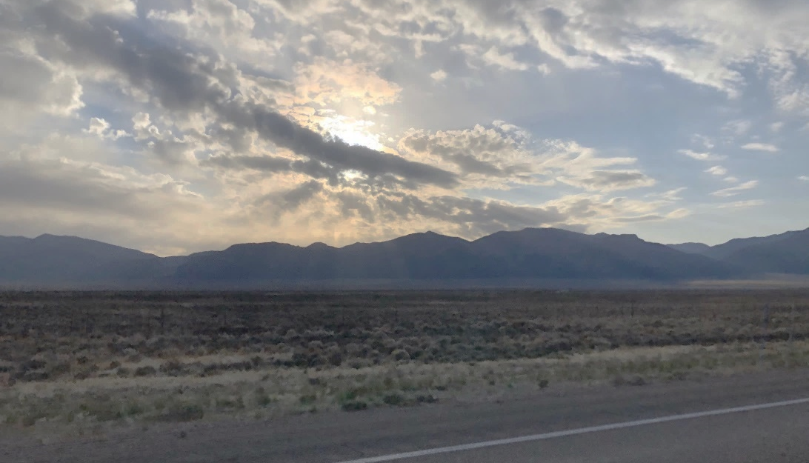
Morning sun breaking through clouds over Highway 318.
Sunday morning, May 16, 2021, somewhere in the central Nevada scrub land, the morning sun peeks through the clouds highlighting surrounding mountaintops. Most people are sleeping at this hour, but I am driving in a miles-long convoy of cars. I’m listening to some favorite tunes and reflecting on the past few days, on the cars around me, and on the great car people I’ve met. The cars range from highly modified racing machines to unmodified road cars, from modern Tesla electric vehicles to vintage Mustangs, the convoy snakes its way through the hills towards lonely section of Highway 318. We arrive at the first stop of the day, Lane’s Coffee Shop and Travel Store near Lund, NV. Here I receive my first friendly greeting of the day from one of the army of volunteers behind this 4-day motorsport event, The Silver State Classic, Nevada Open Road Challenge.
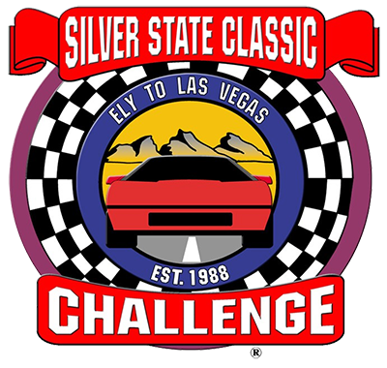
First run in Sept 1988, the weekend culminates in a high-speed Regularity Rally, or Time Speed Distance Rally on a closed section of Nevada Highway. A skill game, the goal is to come as close as possible to one’s target speed averaged over the entire course. Almost any well-maintained road car that can maintain 95mph on the highway can participate and succeed in this competition with minimal preparation.
Cars are sorted into four main divisions based on safety equipment and car preparation: Touring, Grand Touring, Grand Sport and Super Sport. Divisions are further divided into speed classes from 95mph to 170mph. As a rookie driver in Touring division, the highest target average speed available is 110mph, with a range 80-124mph. 25% of participants are in this category with me. Unlimited division cars get a lot of attention in the lore of the Silver State Classic Challenge, they have no target speed, and minimum 160mph. However, they are a relatively small part of the event, with only one entry in this event.
My Silver State Classic experience began 8 short days ago. I was given the opportunity to run the event with a complementary entry presented to Nor Cal Shelby Club from SSCC Inc. Free is free! I got to work preparing myself and my car. The requirements for Touring Division are like our Red/Yellow Group for open track events plus a fire extinguisher, so I was most of the way there.
Side note to anyone wanting to install a fire-extinguisher in their car without modification, look for The Bracketeer, available overnight online. My S550 Mustang friends, I made a small adjustment with a Dremel tool, so it fit securely without modifying anything on my car.
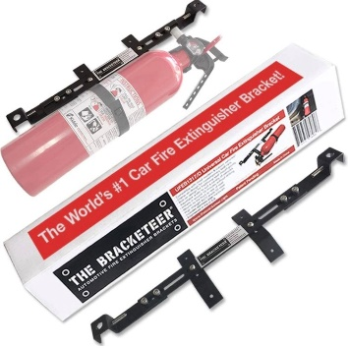
First timers are usually required to attend rookie driving school Thursday morning at Speedvegas in Las Vegas which would have been impossible for me. This is when I first learned the importance of communication with race organizers. After a call and a couple emails, I submitted my GT350 Track Attack certificate from Ford Performance Racing School, and I received a waiver. They will review certification and racing licenses from other organizing bodies, it is worth asking. That said, drivers who attended the driving school were quite happy with the experience. The school offers a selection of performance cars and a fun closed-course with lead-follow instruction.
Thursday drive to Ely, Nevada: Prepared and packed, my journey begins (almost)… Due to a mix up at the installer Wednesday morning, I still need new rear tires. I called Eric Pettersen, the SSCC Tire Guy, expecting to have to cancel my weekend. These things happen all the time, he talked me down, made a call, and found a workable option. I ordered tires will-call from Tire Rack in the hills outside Sparks. I leave a few hours early Thursday morning to allow time to pick up the tires and double-back 30 miles to Reno for install. It seems all of Reno is getting tires today! Lucky for me, I find a Les Schwab that was able to get me on the road in under an hour. A quick refuel for the car and some Del Taco for the driver, and I am on my way to Highway 50, “The Loneliest Highway”, and the gorgeous high chaparral of Northern Central Nevada.
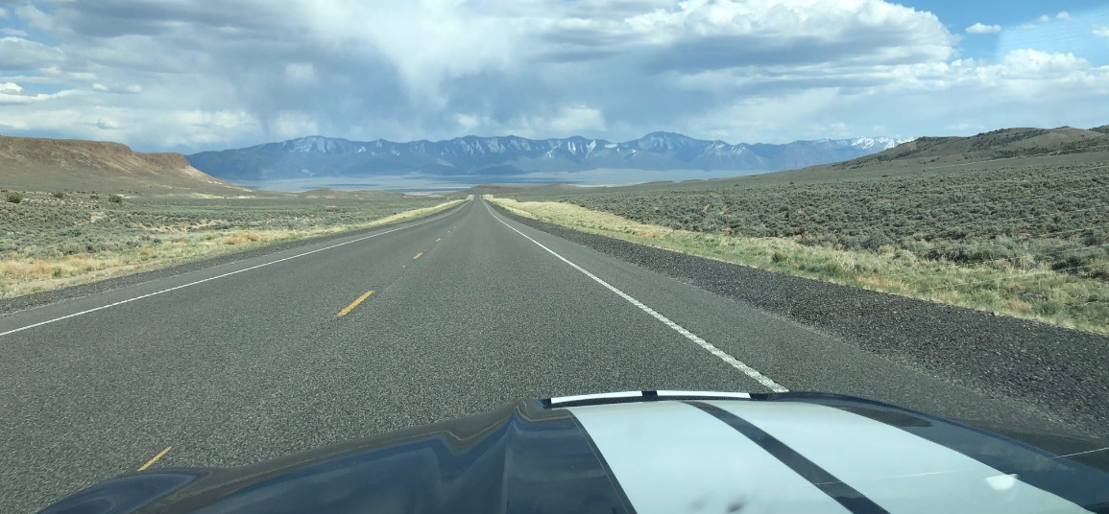
Vanishing Point - My route took me through Austin NV, featured in the 1971 movie.
I arrive in Ely later than I wanted, tired and hungry. I check into a nicely renovated room at the Ramada Copper Queen hotel casino and call Eric. A few minutes later I receive a text with info where to catch up to the SSCC Pub Crawl and walk downtown to meet my new friends and compatriots for the weekend. Eric introduces Rookie Coordinator, Blue Offutt, with his warm, ever-present smile. Blue gives me his contact info and offers to help with anything. Throughout the bar, drivers and longtime friends are enjoying a reunion after 20 months apart due to the pandemic. I meet drivers too numerous to name, including a gentleman who had once taken his Corvair racecar over 200mph, fellow rookie Jim Eakin who brought his unmolested 1967 Ferrari 330 GT-Coupe, and instant friend Abdul Bell who came to the event to help with tech and ended up participating as a navigator. Stories and laughter and adult beverages flow well into the evening. After a couple stops on the “crawl”, I retire for a little food and a bed.
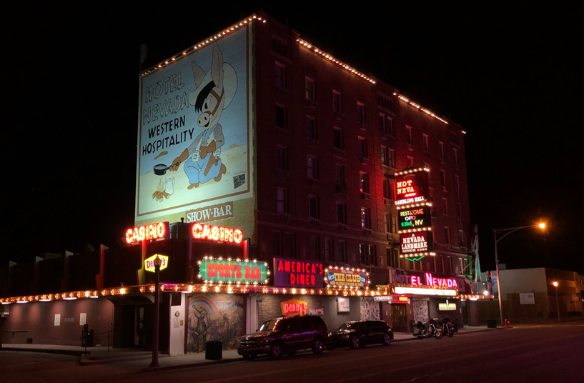
Bright Lights, Little City
A word about Ely, this small town like countless others is emerging from the restrictions brought on by the pandemic. Its main street is hurting, with many closed storefronts. However, Ely is proudly coming back to life. Residents, businesses, and local leadership welcome the influx of loud flashy cars and car people and we happily provide a much-needed jolt to the local economy. Everywhere I go I enjoy friendly relaxed service, I linger some in conversation, I buy a little extra, and I tip a little more. Everyone I encounter is excited for the race, asks about me and my car, and wishes me luck.
Friday morning, I report for registration at the Ely Convention Center, the epicenter of the weekend’s activities. Check in is easy and efficient, I receive car numbers, banquet tickets, and wristbands. Since I registered for the High Noon Shootout, I rush across the street to line up for tech inspection and sign off. This process really stands out to me as a key moment in the weekend, it sets the tone for safety that is central to the event.
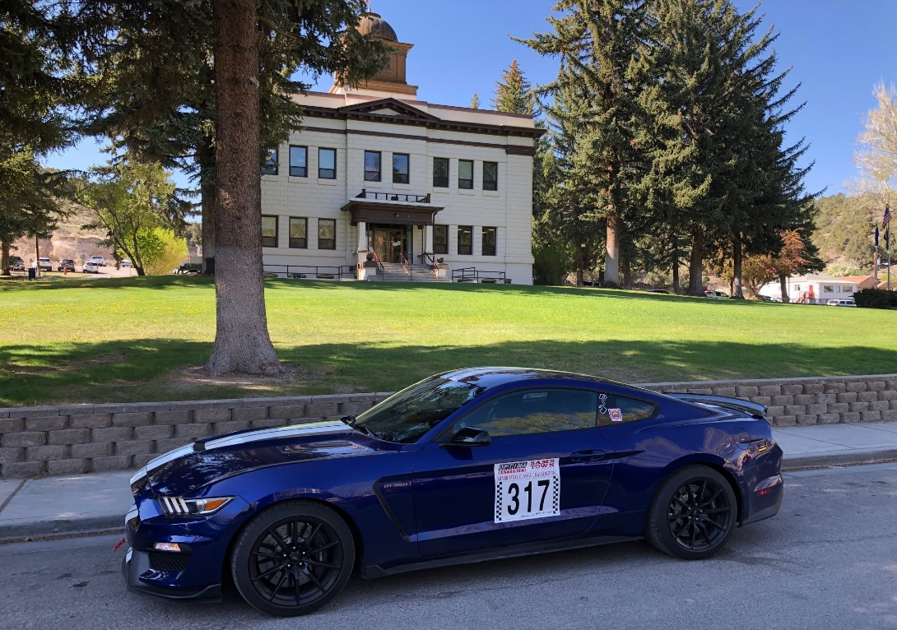
Waiting for tech inspection in front of White Pine County Courthouse
Safety First:
Let’s address the gorilla in the room -- Google “Silver State Classic…” and the top result is “…Crash”, and several results down the list is “…Deaths”. As with all motorsports, there is inherent danger. Most stories of the Silver State Classic focus on Unlimited Class cars and accidents. Accidents have been a rare but tragic part of the event, especially in the early days. In response, the event constantly evolves to constantly improve safety. While no amount of inspection will eliminate driver error, tech inspection seeks to reduce the incident of equipment failure and strictly enforces the safety rulebook.
The rulebook is a living document; its 44 pages contain detailed descriptions, tables, and diagrams clearly stating safety requirements for both car and driver in each division. Learn it and live by it or get turned away. For example, there was a question about my fire extinguisher. I showed that it exceeds the requirement for Touring division and I save myself an urgent trip to the local Ace Hardware.
Special emphasis is paid to tires, as tire failure is a common cause of trouble at high speeds. Recall my last-minute scramble to get new tires, my original equip tires were too old to pass tech. I was in contact with Eric Pettersen early in my planning to confirm these details. After the event he reminded me why he does what he does. He named several drivers that didn’t make it home in the early days of the race. He could not forgive himself if someone was hurt or worse due to an avoidable tire failure occurred under his watch.
For the individual, safety starts in the car which brings me back to tech inspection… Inspectors approach in turns, each signs-off on their specialty. These are experienced volunteers and fellow drivers; they are there to make sure everyone gets home safely.
- Fire extinguisher, type, capacity, mount.
- Cabin check, safety belt, harness (type, age, mount), cage etc as applicable
- Personal equipment, helmet, gloves, shoes, driving suit
- Mechanical, battery mount, fuel-cell, fluid leaks, etc
- Tires, general condition, speed rating, load rating, and date code
- Final review and sign off by the race director, and you get your windshield sticker
Safety extends beyond the car... This specific stretch of road was chosen because the entire 90-mile length is fenced on both sides. Thus, the organizers and law enforcement physically control access to the road and the area around it. Course workers are positioned at some 90 gates the length of the course, keeping an eye and tracking car numbers. Except for a couple short blind-spots, each car is always visible to a course worker with radio communication. Each car is assigned a radio, only to be used in an incident, mechanical or otherwise. In addition to course workers, there is a spotter plane overhead, four ambulances along the course, Sheriff officers from 3 counties are stationed at the entrance, midway and exit of the controlled area. 30+ HAM radio operators facilitate long distance communication. According to Silver State Classic Challenge Inc. Executive Director, Bunny Hill, they, “work closely with Nevada Department of Transportation and law enforcement to provide a safe and enjoyable event for all participants.” The logistics are impressive, and everyone is so professional, the weekend runs like a well-tuned machine.
High Noon Shootout
Registration and inspection behind me, I head North on 93 to the derelict Shepard’s Club Restaurant and Route 490, a straight 2 mile stretch of country road that is home to the High-Noon Shootout. Prepared race cars get one mile, street cars and rookies get a half mile to do their best from a standing start to the finish line where speed is measured between two timing lights. Normally aspirated cars are generally handicapped by the almost 6500 ft elevation. My top result of three runs is 130.118 mph, the fastest I have yet driven in my 2016 Shelby GT350. I may not do this again, but I am happy I was able to try it out.
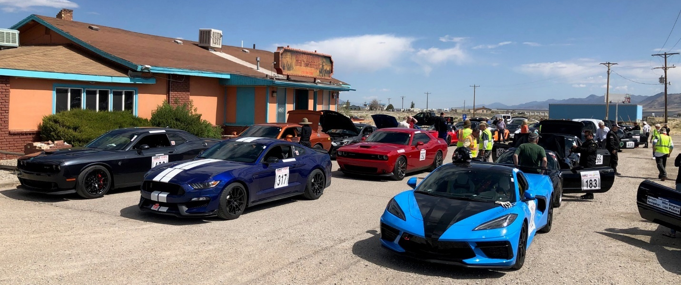
Staging near the High Noon Shootout. Right lane is the 1 mile cars, headed by a gorgeously prepared C-8 Corvette, very friendly solo driver, William V, 115mpg Grand Touring Class. The two left lanes are ½ mile cars. My Shelby surrounded, to get out of Dodge!
After the Shootout, drivers convene at a BBQ lunch in honor of Ray Alexander, a long-time sponsor of the Silver State Classic Challenge, hosted by the Stardust Ranch, the local brothel (legal in White Pine County). I was assured by Rookie coordinator Blue that lunch is hosted outside and is basically family friendly. He recommends that people go and enjoy the lunch, however he and his wife find other lunch arrangements. I too chose to find my own lunch and to wash my car in preparation for the Parade of Cars.
4:00 pm, Cars gather at White Pine High School, Home of the Bobcats, and stage for the parade through town, tossing candy to kids and making lots of noise. Oh, that Voodoo V8 can sing. While waiting for the parade I run into friend, Helen Landis, from Santa Clara Corvettes, and find that she is assembling her team, Adrenaline Junkies, for the team timing competition and I am on it. I went from being a rookie alone and meeting people to being part of an established team, how cool is that?
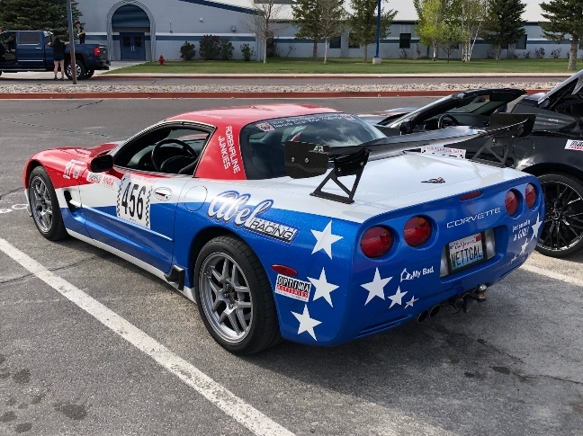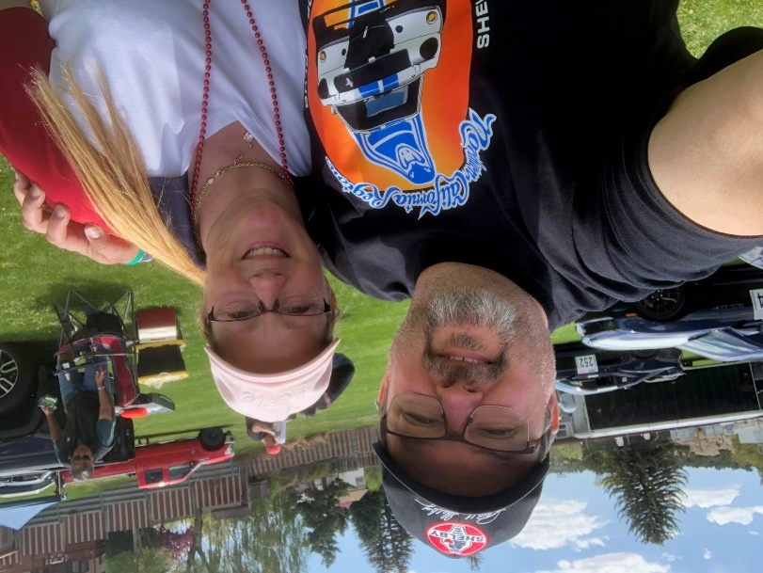
Helen’s Grand Touring 2004 Corvette… Token Ford Driver with Helen Landis, Team Captain of Adrenaline Junkies - Helen first told me about the Silver State Classic about 5 years ago when we met at an autocross and I asked about her car. A year or two later, I found out she is a cousin of one of my oldest friends from childhood. We’re practically family!
The Parade of Cars ends at the Ely Convention Center for a reception and a welcome from White Pine County leadership. After a few addresses and some social time, teams and groups disperse for dinner and other evening activities. Those who wish return to the Stardust Ranch to “compete” for the Coveted Hooker’s Choice Award. The award this year goes for a mere $600 donation (cough… bribe) to the ladies of the Ranch. From accounts, the evening activities at the Stardust Ranch get a little more “adult”, if you know what I mean. After a long day, this author opted for a quiet social dinner with my new team.
Car Show
Saturday morning starts at Broadbent Park athletic field, with all cars assembled on the lawn for the mandatory car show and a nice breakfast prepared by the Ely Lion’s Club. The town turns out to check out the cars and to meet the drivers. Conversations about strategy intensify between drivers and navigators; weather reports, timing sheets and course notes are checked and rechecked. As for me, the nerves are really beginning to settle in. I still manage to try to meet some other drivers and learn about their cars.
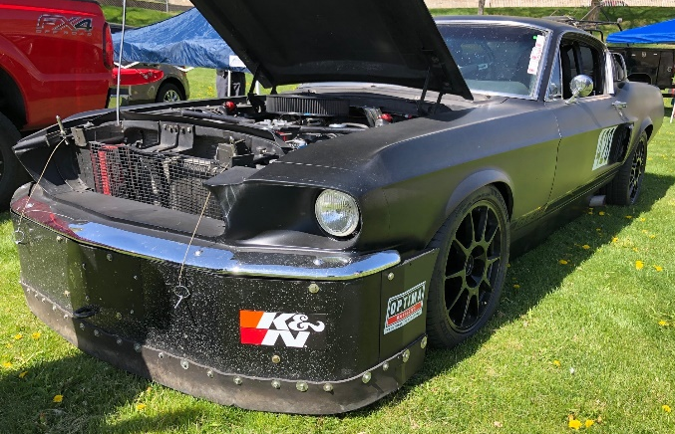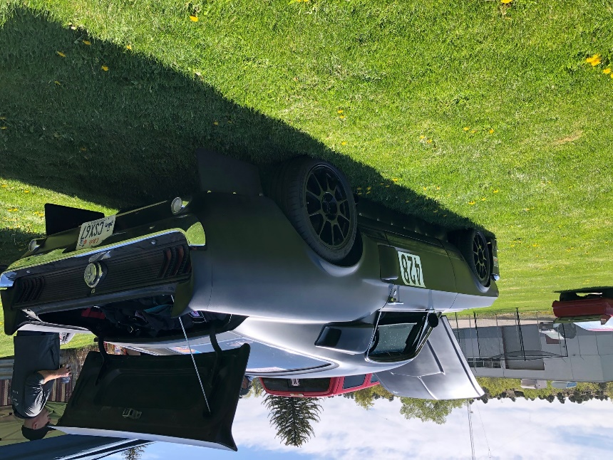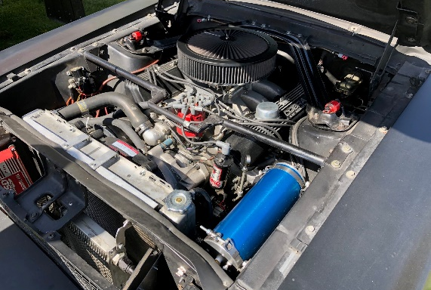
Blaine Spendlove, 1967 Mustang Fastback, Grand Sport Division 155mph class: Love at first sight, I saw this menacing matte black fastback speed machine drive in and knew I had to find out about it. It’s from my birth year after all. Spendlove bought his 1967 Mustang Fastback in ’93 and has built and refined it by himself since. He began running the Silver State Classic in 2013. The main body is all original steel with fiberglass hood and trunk, hand-made conveyor belt ground effects skirt the car. Under the hood is an all-aluminum 427 Shelby engine. For what it’s worth, Spendlove told me that when the engine was built in the early 2000’s, the engine builder had it registered with Carroll Shelby Motors, CSX 1067.

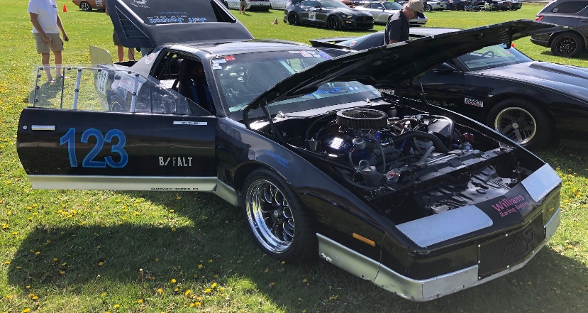
Randy Rocket Rideout, ‘82 Pontiac Trans Am, Super Sport Division, 160mph class: Rideout purchased his donor car, in ’92. It had rolled off the factory floor with a four-cylinder lump producing a maximum 110hp. The car currently runs a small block 423, producing significantly more horses… rookie reporter mistake, I forgot to ask. Rideout runs the car at Bonneville, where he has exceeded 200 mph. His long-term plan is to run over 200mph in the Silver State Classic. This event was a shakedown run after a year-long hiatus.

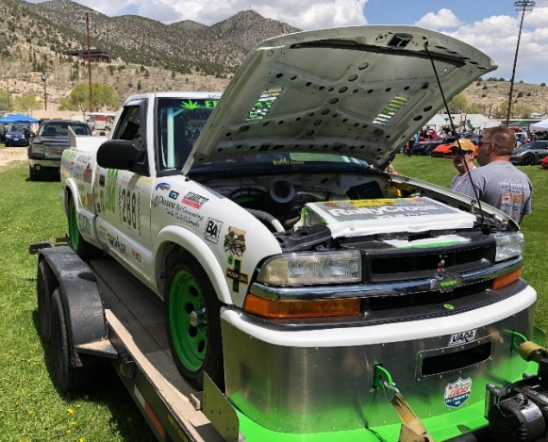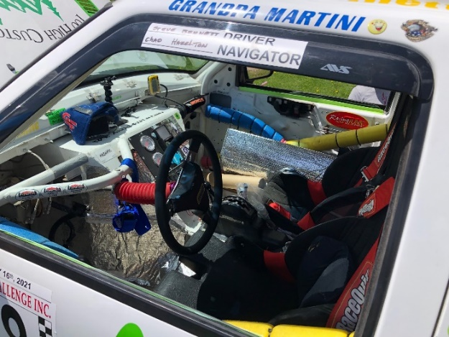
Steve Bennett, Pahrump, NV, 2003 Chevrolet S-10 Pickup (that’s what I said), Touring Division, 105mph: Hill-climber Bennet is here to test out a new small block powerplant. He could certainly run in higher speed classes but that’s not his end game. He is a 5 times starter and 5 times finisher of the Pikes Peak International Hill Climb. He said he could have gone home a happy man after “winning” the Hookers Choice Award.

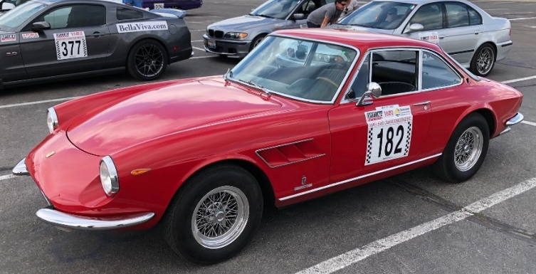
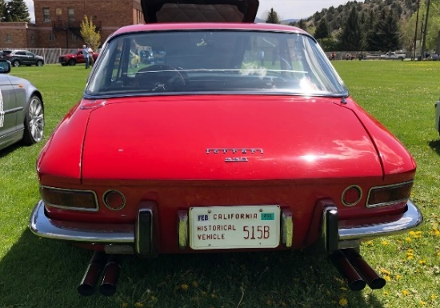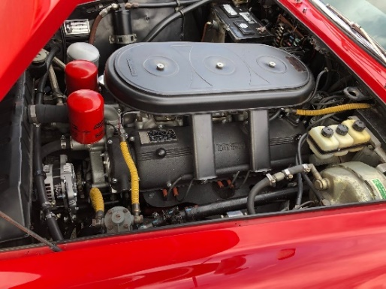
Jim Eakin, 1967 Ferrari 330GT Coupe, Touring Division, 95mph: 3rd Place in class and winner of the Hearts Delight Award at the Car Show. Rookie hero Eakin drove this dream car, some 800 miles from Big Bear Lake, CA to participate.

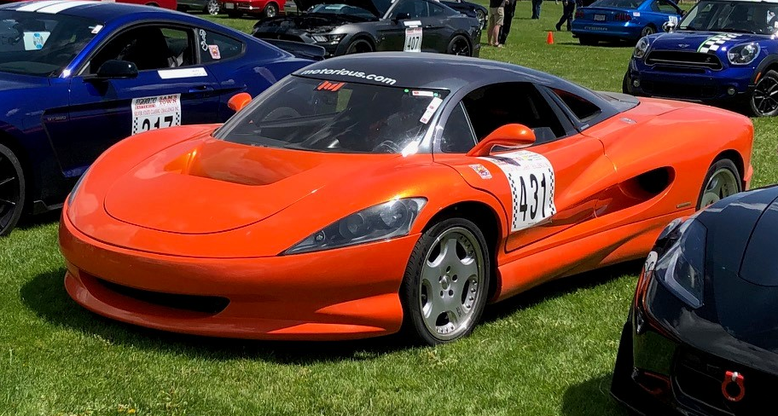
John Misumi, Vision SZR, Grand Touring 125 mph: Winner of the Most Interesting Car in the Show, this literal one of a kind car is the sole brain-child of Misumi. Started 1998, finished in 2008, this Scissor-doored, mid-engined supercar It is propelled by a GM Ram Jet 502 crate motor. This was his third time running with in a Silver State Classic Challenge event.
Some notable Fords with drivers I met briefly throughout the event but was unable to talk with in detail.
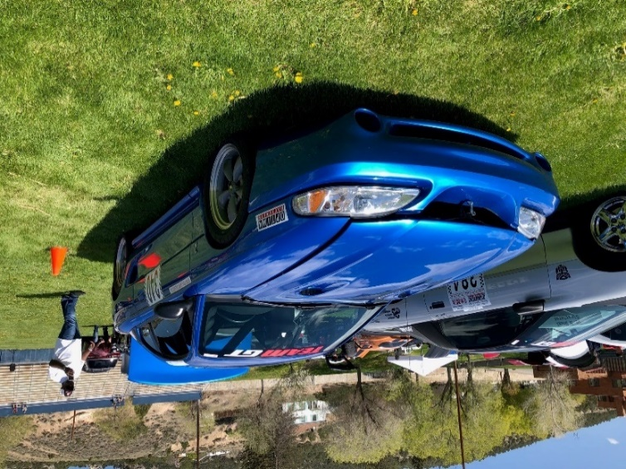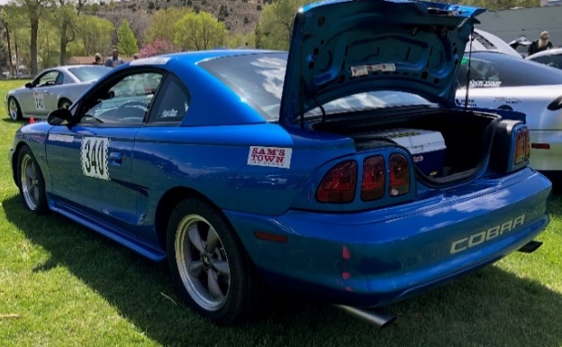
Ted May’s 1992 Shelby Cobra Mustang, Grand Sport, 135 mph: I met Ted on grip for the ½ mile Shootout. Nice guy, I’ll look for him at future events.
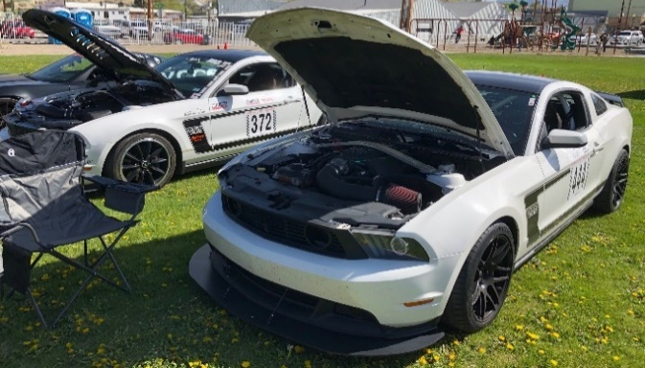
The Boss Twins, License plate frame on one reads, “Porsches for Breakfast, Ferraris for Lunch”

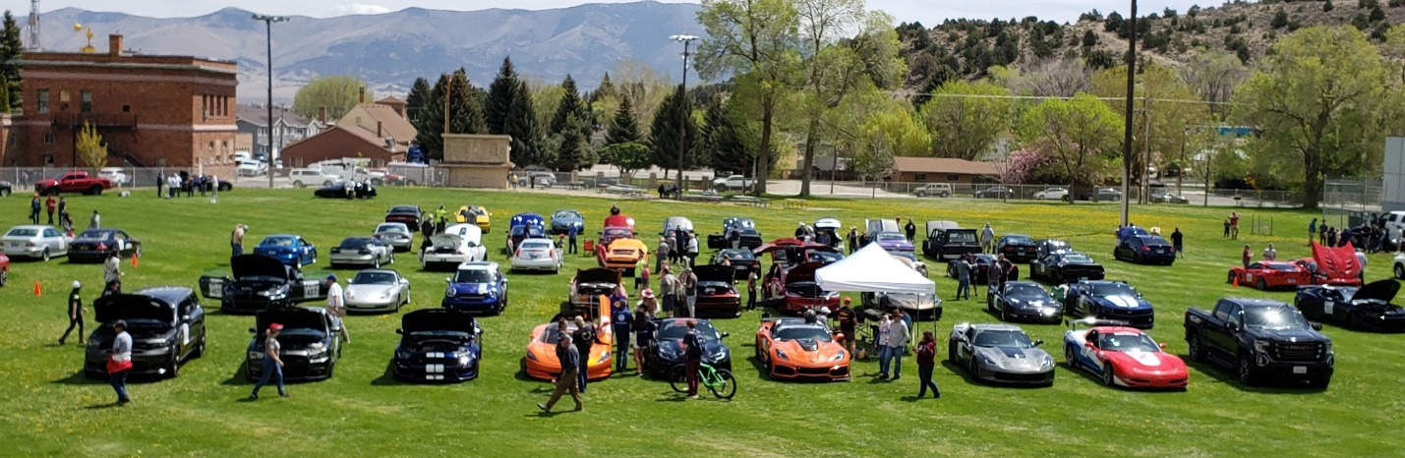
A picture of our team, Adrenaline Junkies in the front row. Dodge Durango, Dodge Challenger, Ford GT350, Vision SZR, and 4 Corvettes… oh yeah, and a tow vehicle.

Saturday afternoon, after the Car Show and a lunch with some team members, I popped over to the Nevada Northern Railway Museum. I did not allow enough time to take the rail tour, but I enjoyed my time wandering about the grounds and taking a quick look in the extensive machine shop. I recommend spending a few hours.
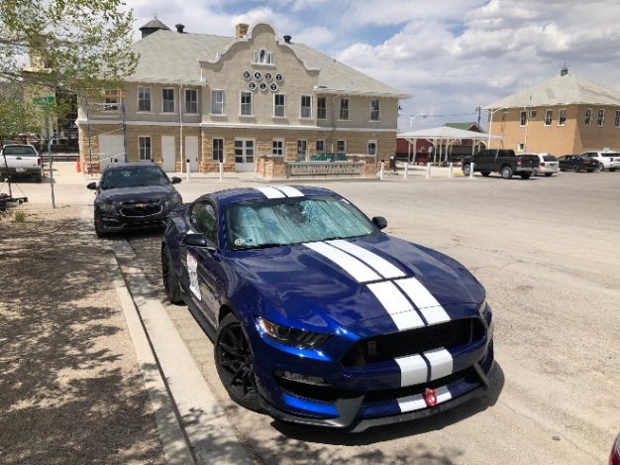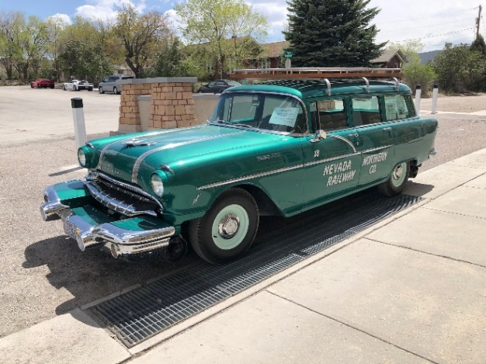
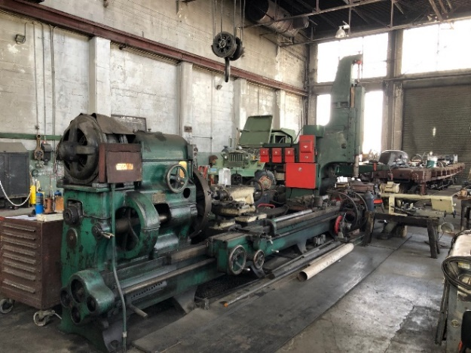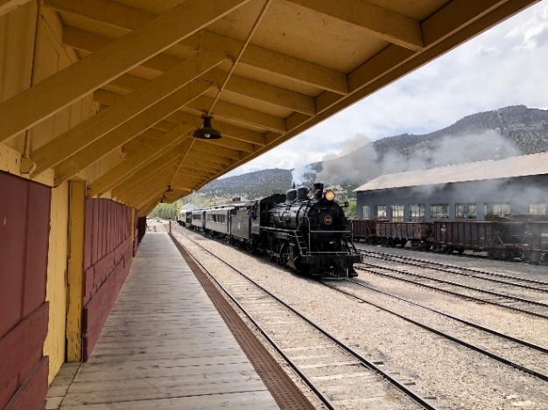
The Old Station Building, 1956 Pontiac Hy-Rail rail car, hard to see, but has retractable rail wheels, Big engines need big machines, and Steam train tours operate throughout the day
Saturday Drivers Meeting
At 4:00 the business of the Nevada Open Road Challenge begins in earnest with a mandatory meeting for all rookie drivers and navigators. Course notes with mile markers and corresponding times are available for each Target Speed Class. General advice and information are presented. The rookie meeting is followed by the mandatory Drivers Meeting: grid positions are assigned, flags, course markers, and emergency procedures are reviewed, and final instructions are given. Business concluded, we all go our separate ways to do whatever we can to rest and prepare for the event. “Sleepless Saturday” is a restless night for many, me included.
SUNDAY! SUNDAY! SUNDAY!
It’s the big day, well almost, the sun won’t be up for a while yet. Cars roll through town and line-up at the park to caravan some 40 miles to Lane’s Coffee Shop and Travel Store. Lane’s is the last pitstop, and last chance for gas before the start. It is recommended that drivers meet and check strategy with those in adjacent grid positions. There is little chance that cars will meet on the road, but it does happen, and it’s good to have a plan. Volunteers and staff assign each car a radio and send cars out in grid order. A few slow miles later, on the south end of Lund, drivers are waved through the Sheriff’s Road Closure. Past this point, Highway 318 belongs to us for the day.
About 25 miles later, cars pull through the Sunny Side Rest Area for final grid instructions and on to the start line. As grid position 64, I knew I had over an hour to wait, so I walked around and chatted, and watched the unlimited entry disappear down the road in a cloud of noise and tell-tale smoke. The lone unlimited group entrant failed to make it 10 miles into the course on this day. 5 minutes later, the next to launch were the 170mph class at 3-minute intervals. Other classes followed at 1-minute intervals for about an hour until I got the call. About 10 minutes before my start, I secured my cabin, and put on my safety gear.
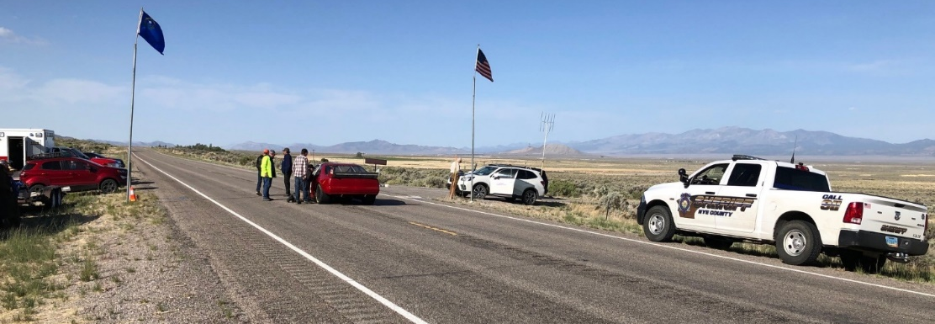
Waiting for 08:00 and the start of the Southbound leg
As I begin to roll towards the line, I am met by the last safety inspection, Cabin Check. Both doors are opened, I am inspected for helmet, gloves, shoes and apparel, and the cabin is checked for anything loose. They wish me good luck and sent me to the line. 2 minutes to go, the car before me in the side by side formation goes, I see nothing but open road ahead as I pull up to the line. 1 minute to go, the driver next to me takes off, and the flag man comes to my corner showing 1 finger. We exchange thumbs up, and I turn my focus to the clock.
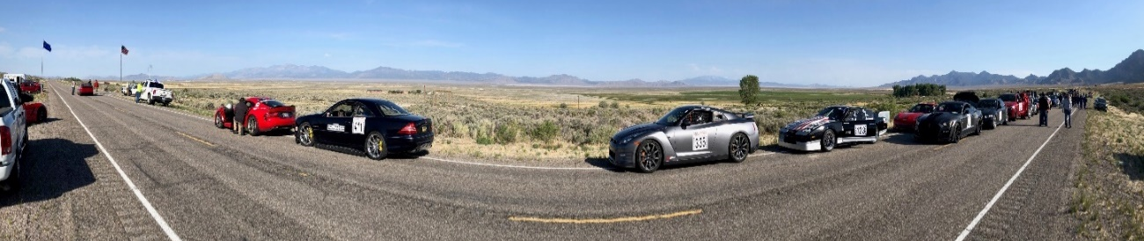
5-4-3-2-1-Go - I start the timer on my dash and then take to the course. It’s not a drag race with smoking tires and burning clutch, it’s about starting the timer on the mark and taking to the course. I have miles ahead to make up time and to adjust my speed to meet my target time. I run up to about 115mph for the first few miles until my mile marker time gets close to the target, then I settle in for the mid-course. It was around Flag Station 6 that I noticed my timer had reset. I had no time-base to reference. I consider my options (none), run 110mph, and hope for the best. Another GT350 driver had the same experience; after 15 minutes, the built-in lap timer resets, a serious flaw and a tough lesson learned.
11 miles after Flag Station 6 is the Narrows, the tightest section of the course. I scrub some speed, navigate the curves of the canyon, and exit the section about 90mph. I run for several miles at 115mph, before settling back to 110mph. There is a long straight where I could just spot the car ahead of me. I try to time my gap, since I knew he had run several times before, I trust he wouldn’t make a timing mistake. Unknown by me until official results were posted later in the evening, I finish the first leg 15 seconds ahead of my target time.
At the turnaround I top off the tank, reset my brain, borrow a stopwatch from team captain Helen, and try for my best target time on the way back. On the return, I learn the next hard rookie lesson, always have two stopwatches. About 5 miles from the finish, I press the wrong button and stop the time instead of holding a split time. Again, I am without a time base. At least I am close to the finish and I have tuned my ear to the changing engine note as I traverse rolling hills and gentle curves. My northbound time variance is +4 seconds, for a total variance of 19.2057 seconds, a lifetime in this game of skill. The winner of 110mph Touring Class missed target by 0.1173 sec, with 7 of 24 cars less than 1 sec from target.
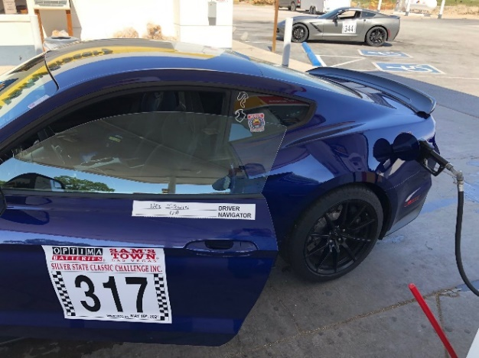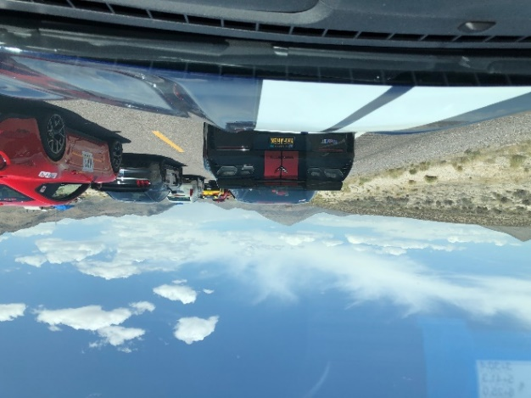
Stay Thirsty, my friends. North-bound Grid
The Finish Gathering -
About a mile past the finish, all cars pull into the Sunny Side Rest Area. Arrivals are announced and given a finishers dash plate. Participants gather with teammates and friends, cheer each successive arrival, and swap stories. After the final arrival, all present gather for Rookie Graduation and an invocation from the King of Highway 318, who resembles Rookie Coordinator, Blue Offutt. Then the convoy is on the road again for the relatively quiet, painfully slow drive back to Ely. Note… Drivers face disqualification if they are caught speeding in the area 90 days prior to the event or day of, the local police will contact race organizers.
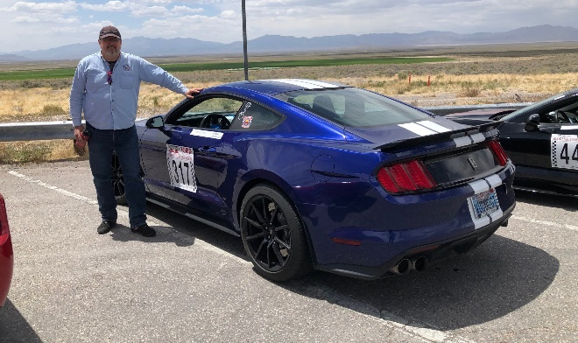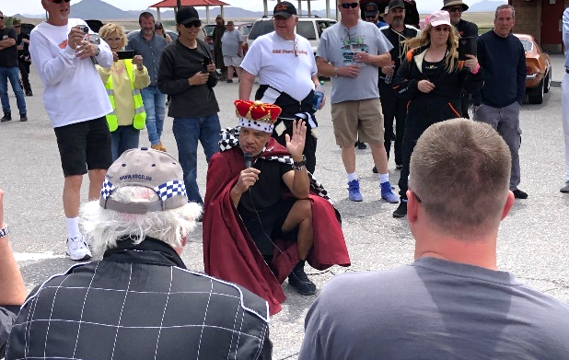
Still Shiny! Rookie Graduation, The King of Highway 318!
Team Adrenaline Junkies beeline to Margarita’s Mexican Restaurant for what else, a margarita and a hearty lunch. During lunch a local mom approaches the table with her two star struck daughters. The shy kids are fans of the event and want to meet some drivers, especially the driver of the red white and blue corvette. Helen hops into action, taking the girls for a tour of her car. They return with glowing smiles, proudly showing off pictures and leave with memories that will last a lifetime. The seeds for the next generation of racers are sown and taking root.
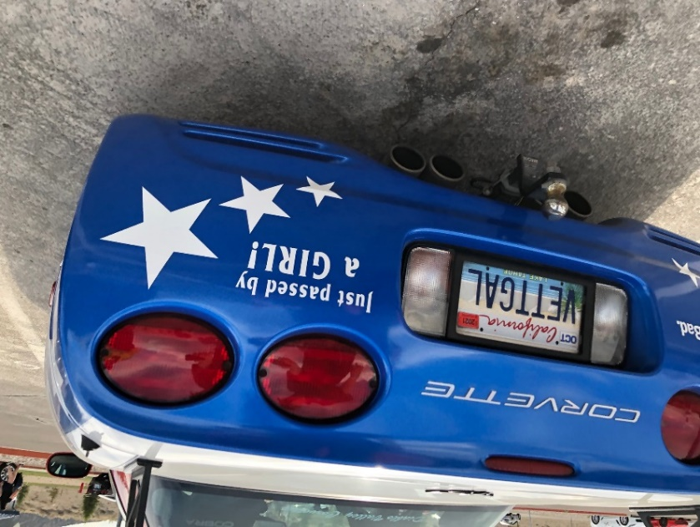
Helen Landis’s Corvette - Built to inspire girl racers!
Awards Dinner
Drivers, course workers, families, and friends come together one last time Sunday evening to share a meal, to swap stories and contact information, and to award the most precise drives of the day. I won’t list the results here, they’re online. I will note that team captain Helen Landis and her co-driver Mim Peterson won the 125mph Grand Touring class, swapping seats and duties at the turnaround. Time variance 0.5564 sec. Doing so, they won the Hand Timing Award, they drive with nothing but stopwatches and paper lists of mile-markers and waypoints.
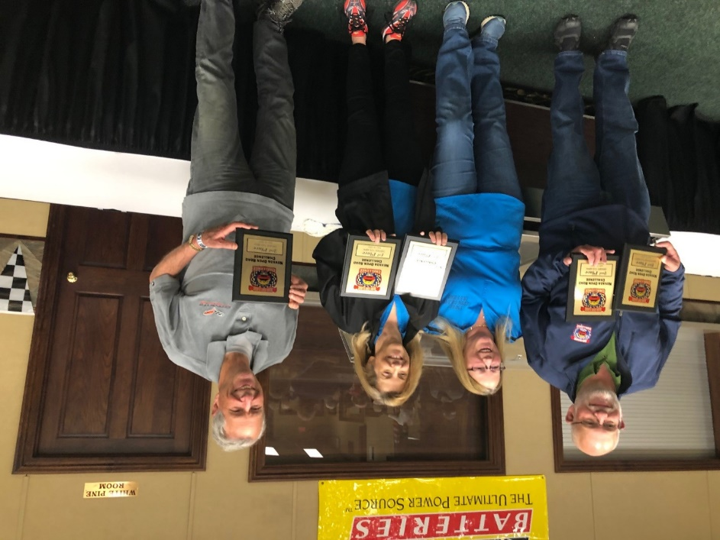
Tim Zimmerman 2nd 135mph, Helen Landis & Mim Petersen 1st 125mph, Don Herzer, 3rd 135mph
The evening is typical of other banquettes I have attended over the years, punctuated by poignant moments after the 2020 cancellations. It is happily noted that while the field was small, it about 30% rookies, giving organizers and competitors hope that the race will continue and grow. I know I will return to run again; like captain Helen says I’m caught, “hook, line, and sinker.”

